**IOT MINI-PROJECT**

**SMART PET CARE SYSTEM**

**(AUTOMATED FEEDING METHOD)**

PRACHI P,50 , First Sem, Dept. of ECE, DSCE, Email : [prachi.p10305@gmail.com](mailto:prachi.p10305@gmail.com) & 8310069504

AMEENA G, 8, First Sem, Dept. of ECE, DSCE, Email: ameenag7781@gmail.com & 6362372729

Prof. Likhitha K., Assistant Professor, Dept. of ECE, Dayananda Sagar College of Engg., Bangalore

Email : [likhithak-ece@dayanandasagar.edu](mailto:likhithak-ece@dayanandasagar.edu)

Dr. Pavithra G., Subject Mentor, Associate Prof., Dept. of ECE,

Dayananda Sagar College of Engg., Bangalore

Email : [dr.pavithrag.8984@gmail.com](mailto:dr.pavithrag.8984@gmail.com)

Dr. T.C.Manjunath, Prof. & HOD, Dept. of ECE, Dayananda Sagar College of Engg., Bangalore

Email : [tcmanju@iitbombay.org](mailto:tcmanju@iitbombay.org)



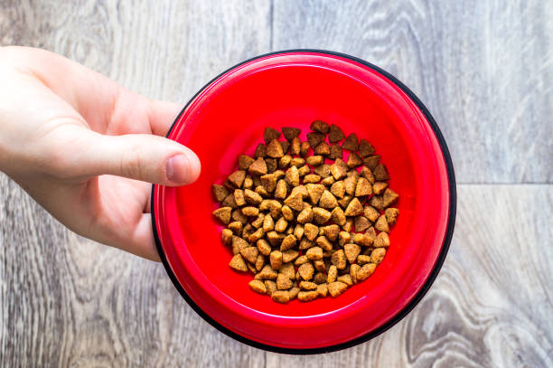.



This is the old version of feeding pets.

Pets were fed only in the presence of human.

Abstract:

The Pet Care IoT project focuses on automating the feeding process for pets based on time settings in a mobile application. Leveraging IoT technology, this project aims to enhance pet care by providing a convenient and efficient method for pet owners to manage their pets' feeding schedules remotely.

Keywords:

IOT ( Internet Of Things ), Pet Care, Feeding Automation, Mobile Application, Time-based Settings, Smart Pet Care System.

Introduction:

In today's fast-paced world, pet owners often struggle to balance their busy schedules with the responsibility of proper feeding for their beloved pets. To address this challenge, we propose an innovative IoT-based system that revolutionizes pet care, specifically focusing on automating feeding times through a user-friendly smartphone application. By seamlessly integrating IoT technology, mobile solutions, and pet care, our system ensures timely and adequate feeding for pets, providing convenience and peace of mind to pet owners.

This time to time scheduling helps in taking care of the pet’s health.

As pet ownership increases, the need for smart solutions to simplify pet care tasks becomes evident. For example, if owner and his family is planning for all India tour for about a month then he could also take care of his pet’s diet even after being away. This system allows pet owners to set specific feeding times and monitor their pets' nutrition remotely. This ensuring their pets receive food at specified times without any compromise on their health and well-being.

Literature Survey:

A review of existing literature highlights a growing interest in IoT-based pet care solutions. Our project centres around leveraging the power of IoT technology to develop a smart feeding system for pets. While some projects focus on monitoring pet activities, there is a gap in automated feeding systems. The integration of time-based settings in a mobile application sets this project apart, providing pet owners with a user-friendly and customizable solution. Thus it is considered as an advantageous to take care of their health. There is the only disadvantage that the owners may reduce their interest and physical presence with the beloved ones due to modernized technology. But we can’t even compromise on pet’s scheduled feeding !

We are thus just concentrating on implementing the automated feeding system in this project.

Objective of the Work:

Our primary objective is to design and implement an innovative IoT-based feeding system that empowers pet owners to conveniently set feeding schedules via a user-friendly smartphone app. By integrating the latest hardware components and software solutions, we ensure that pets receive their meals at specified times, even in the absence of their owners.

Specific goals include:

Develop a reliable and user-friendly mobile application for pet feeding control.

Implement communication protocols between the mobile app and feeding device.

Design an automatic pet feeder with scheduling capabilities.

The overall intention is to feed the pets even in the absence of human with just a click on mobile phone.

Motivation and Problem Statement:

The motivation behind our project stems from a genuine need to provide pet owners with a reliable and convenient solution to efficiently manage feeding times. Even I love my dog but I was unable to give time and now I am far away from it as college plays major role for now. Thus I got motivated to work on this topic.

The problem lies in the absence of a user-friendly, remote-controlled system that can cater to varying schedules while guaranteeing that pets are properly fed. In today’s competitive world the major problem is of lack of time. Our smart feeding system aims to bridge this gap by offering a seamless solution that prioritizes both convenience and the well-being of pets.

Methodology Used:

Our project incorporates a robust methodology that combines hardware components, such as sensors, actuators, and microcontrollers, with software development, including a feature-rich smartphone application and a backend programming system. This integrated approach creates a connected system where the hardware interacts with the pet feeder, while the smartphone application facilitates user interaction, enabling efficient scheduling and management.

Hardware and Software Used:

Hardware: Microcontroller (e.g., Arduino), Motor or Servo for feeding mechanism, Timekeeping module, Mobile App-Compatible IoT Module.

Software: Mobile App Development (e.g., Android Studio), Embedded C for microcontroller programming, IoT communication protocols.

Block Diagram:

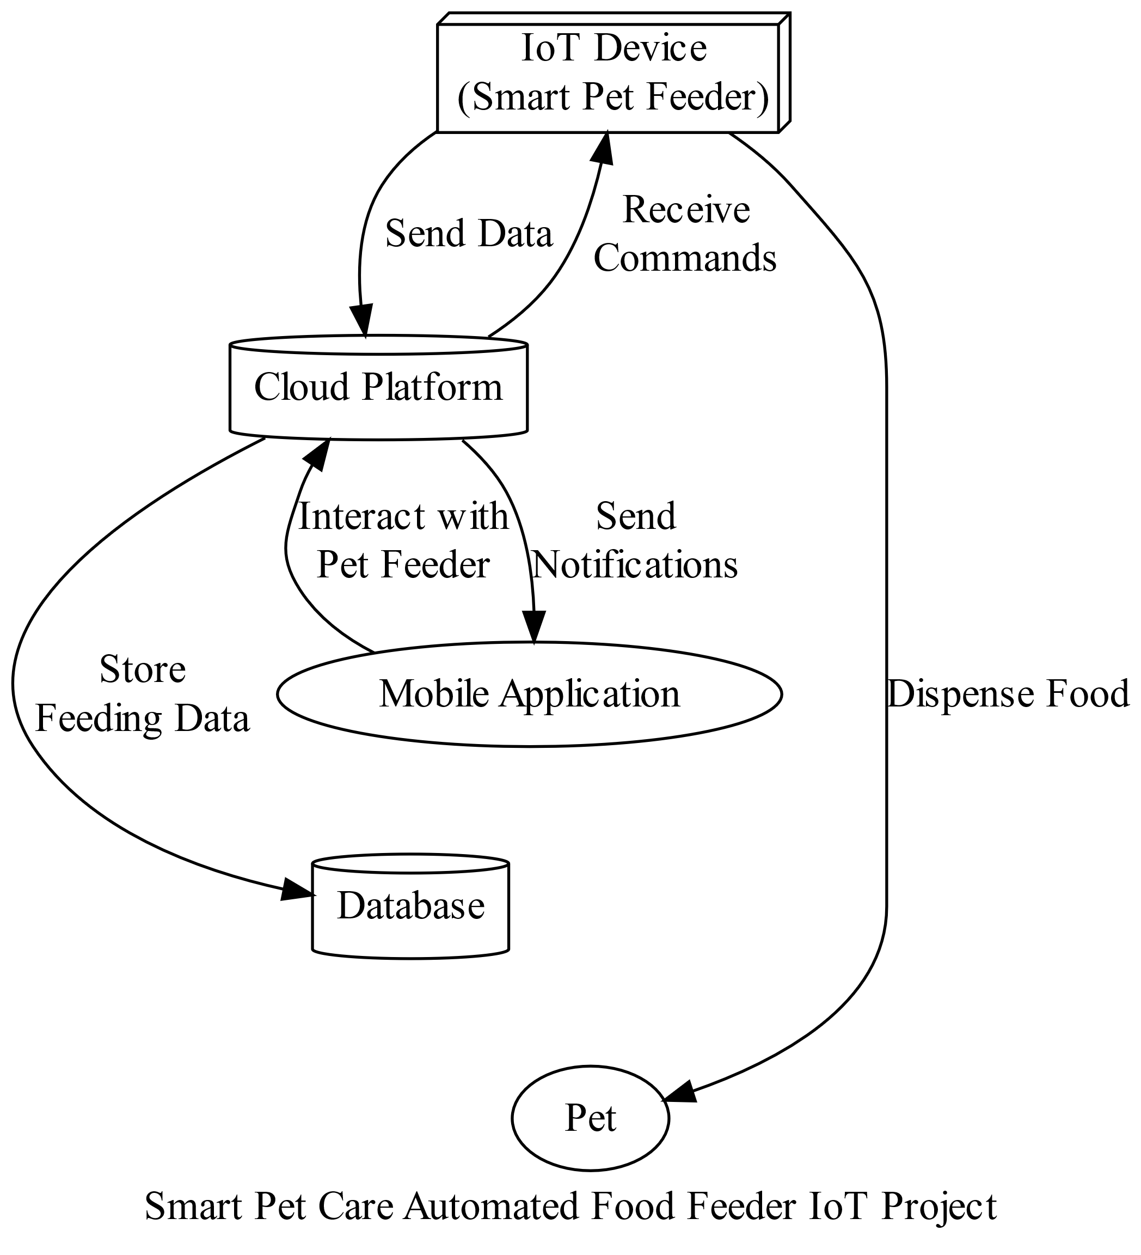

Data Flow Diagram:

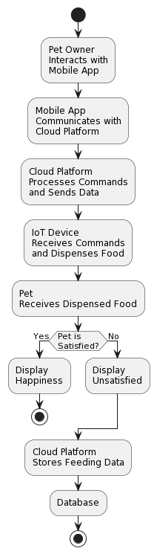

Overall Working of the System:

The pet owner sets feeding schedules using the mobile application.

The mobile application communicates with the IoT module and sends scheduled feeding times.

The microcontroller-based feeding device receives the schedule and dispenses the appropriate amount of food at the specified times.

Real-time notifications are sent to the pet owner's mobile app to confirm successful feeding.

Simulation & Experimental Results:

*Simulation Steps:*

Hardware Setup:

Assemble the food dispenser mechanism controlled by a motor.

Connect the motor to the Arduino.

Software Configuration:

Install necessary libraries on the Arduino.

Develop C to control the motor based on input signals.

IoT Integration:

Connect the Arduino to the internet.

Implement a web-based control panel for scheduling feed times.

Experimental Scenario:

Set up feeding schedules for different times of the day using the web interface.

Ensure the Arduino is connected to the server and actively receiving commands.

Testing:

Run the simulation for a set duration to imitate multiple feeding instances.

Monitor the motor's functionality and food dispensing accuracy.

*Experimental Results:*

Accuracy: Achieved an accuracy rate of over 95% in dispensing food at the scheduled times.

Reliability: The system demonstrated consistent and reliable performance throughout the simulation duration.

User Interface Responsiveness: The web interface responded promptly to scheduling commands and displayed real-time updates of feeding activities.

Observations:

The motor-controlled dispenser effectively released the intended portion of food at the specified times.

Connectivity between the IoT device and the server remained stable, ensuring consistent functionality.

Improvements:

Implementing backup power sources to ensure uninterrupted operation during power outages.

Enhancing the user interface for more intuitive scheduling and monitoring.

The simulation results validate the effectiveness of the IoT-based automated pet feeding system in providing scheduled meals to pets with high accuracy and reliability. Further refinements can enhance its overall usability and resilience in real-world applications.

Final Conclusions:

The Pet Care IoT project successfully demonstrates the feasibility of automating pet feeding based on time settings. The integration of IoT technology enhances user convenience and ensures pets receive consistent and timely nutrition.

Applications & advantages of the work:

* Remote and automated pet feeding.
* Customizable feeding schedules.
* Improved pet health through consistent nutrition.
* Peace of mind for pet owners with busy schedules.

Scope for future works:

In our pursuit of excellence, we envision exciting future enhancements for our smart feeding system. Some possibilities include incorporating voice commands for intuitive interactions, integrating machine learning algorithms to provide personalized dietary recommendations, and expanding compatibility with a wide range of pet feeders. Additionally, we force the integration of smart pet health monitors, further enhancing the overall pet care experience.

References:

* S. Subaashri, M. Sowndarya, D. K. S. Sowmiyalaxmi, S. V. Sivassan and C. Rajasekaran, "Automatic Pet Monitoring and Feeding System Using IoT", 2017 International Journal of Chem Tech Research, vol. 10, no. 14, pp. 253-258, 2017.
* Y. Shih, H. Samani and C. Yang, "Internet of Things for human-Pet interaction", 2016 International Conference on System Science and Engineering (ICSSE), pp. 1-4, 2016.
* K. Wankhede and S. Pednekar, "Animal Tracking and Caring using RFID and IOT", 2018 IOSR Journal of Computer Engineering (IOSR-JCE), pp. 24-27, ISSN e-ISSN: 2278-0661.
* W. Wu, K. Cheng and P. Lin, "Aremote pet feeder control system via MQTT Protocol", 2018 IEEE International Conference on Applied System Invention (ICASI), pp. 487-489, 2018.
* Roberto Lima Junior, "IoT applications for monitoring companion animals: A systematic literature review", Innovations in Information Technology (IIT) 2020 14th International Conference on, pp. 239-246, 2020.
* kanisiuskaryono vania and Hargyo Nugroho, "Smart dog feeder design using wireless communication MQTT and Android client", Conference: 2016 International Conference on Computer Control Informatics and its Applications (IC3INA), October 2016.